**Task #1**

**1- What are configuration management tools, why would I use them?** [1]

* Configuration management tools are server Orchestration or IT Orchestration since these tools are typically capable of managing one to hundreds of servers from a central controller machine. They are available in the market (Puppet, Ansible, Chef, and Salt are popular choices).
* Each tool will have its own characteristics and work in slightly different ways, they are all driven by the same purpose (make sure the system's state matches the state described by your provisioning scripts).
* Most configuration management tools use a controller/master and node/agent model.
* Essentially, the controller directs the configuration of the nodes, based on a series of instructions or tasks defined in your provisioning scripts

**2-What is Ansible and what exactly makes Ansible unique? [2]**

* Ansible is a powerful IT automation (automate even the most complex deployments), simple enough for everyone in your IT team to use.
* Ansible handles repetitive tasks (giving teams the focus on innovation).
* Red Hat, Ansible, Tower expands IT automation to your enterprise adding control, knowledge, and delegation on top of Ansible’s automation engine.
* **Understand Ansible structure, Understand playbook, Understand Roles.**
* **YAML and understand the basic of yaml syntax.**

**Task #2 - Hands on ansible  
  
1-Install and configure Ansible on your local machine.**

* Install Ansible:

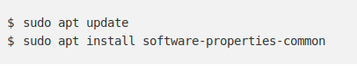

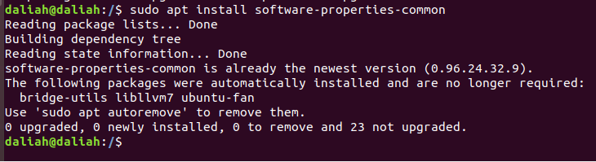

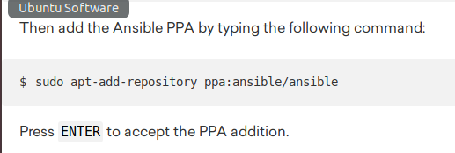

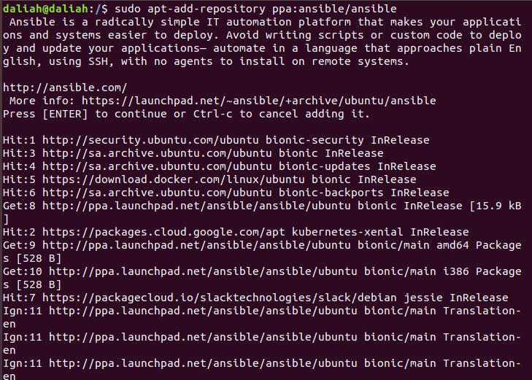

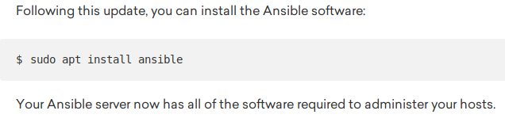

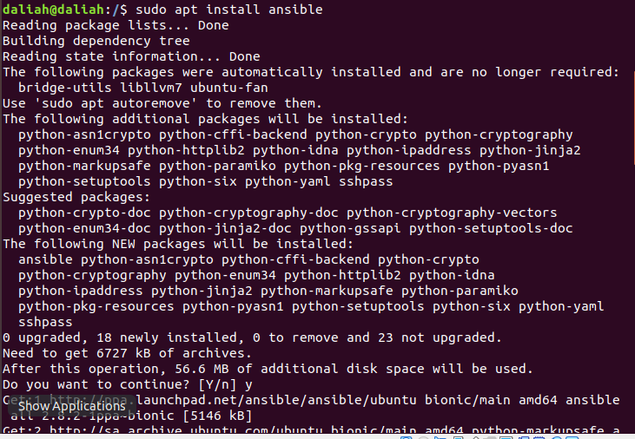

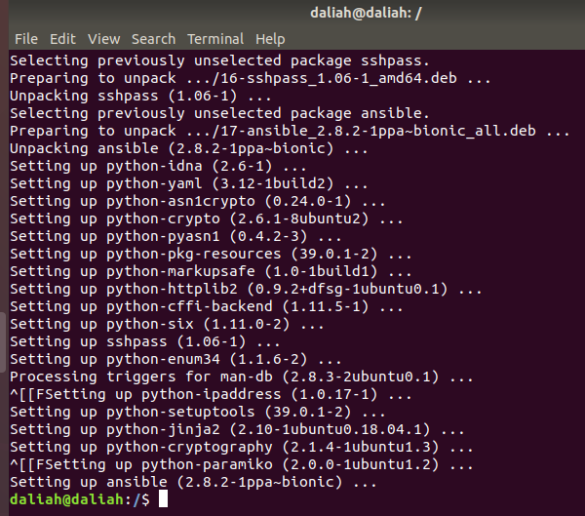

* Configurting SSH Access to the Ansible Hosts:

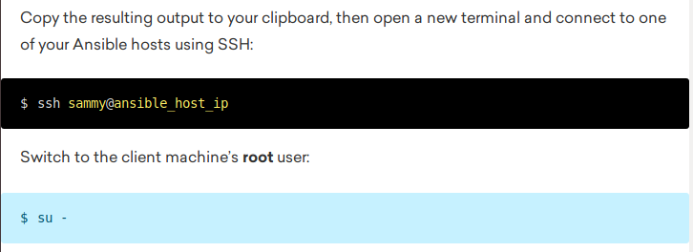

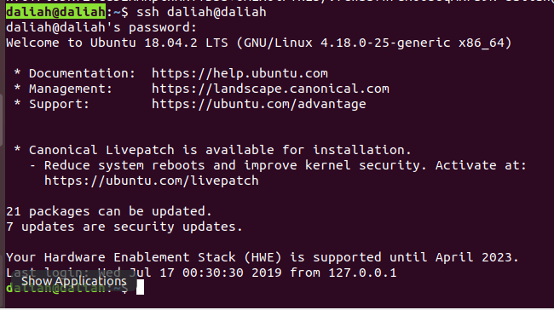

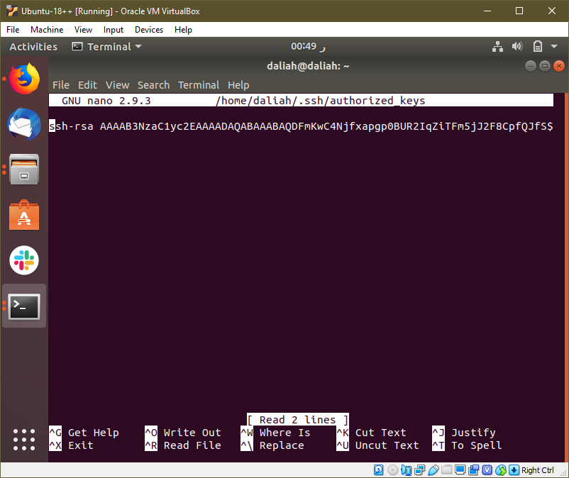

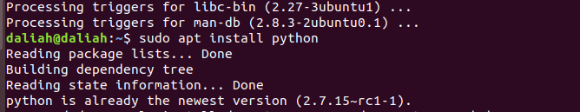

* Setting up Ansible Host :

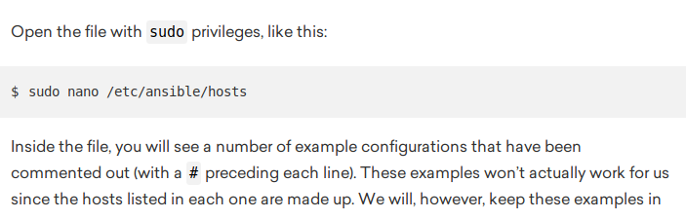

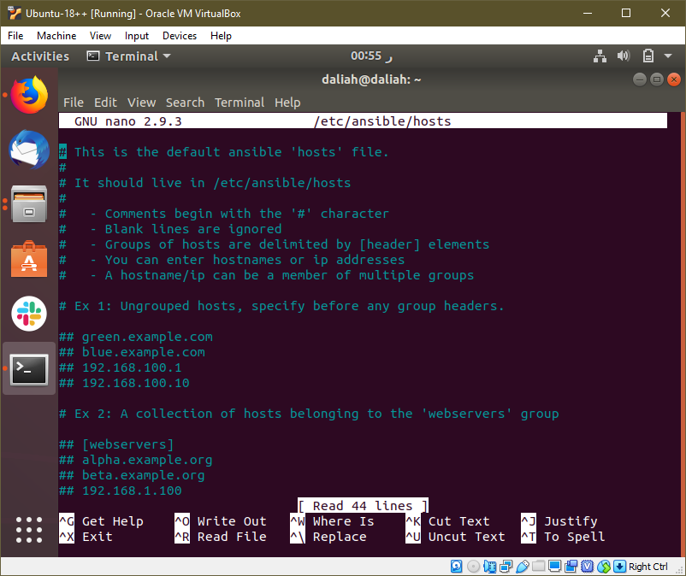

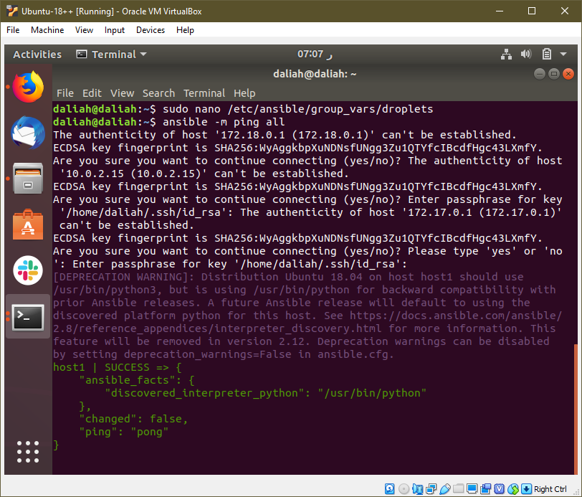

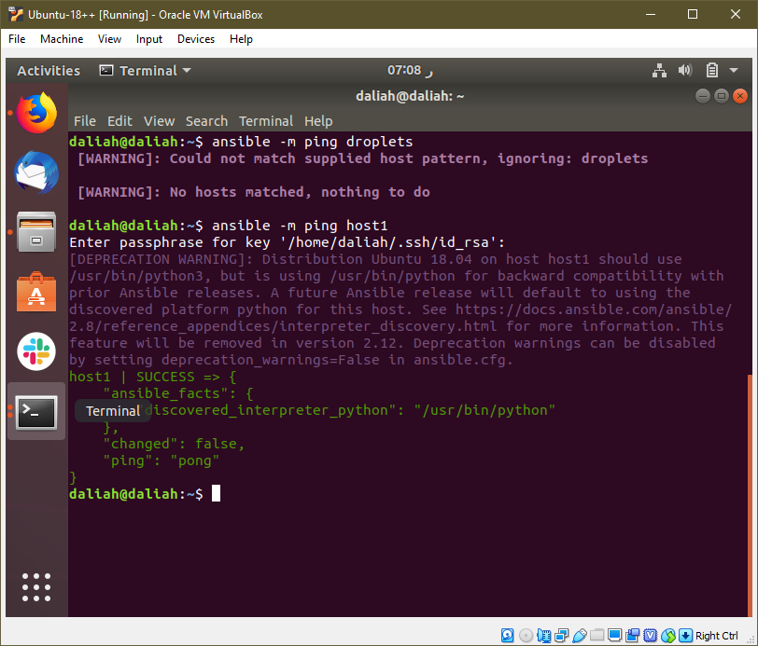

**2-Write a playbook that “ping remote host”.**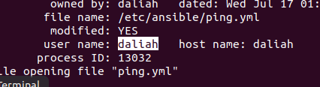

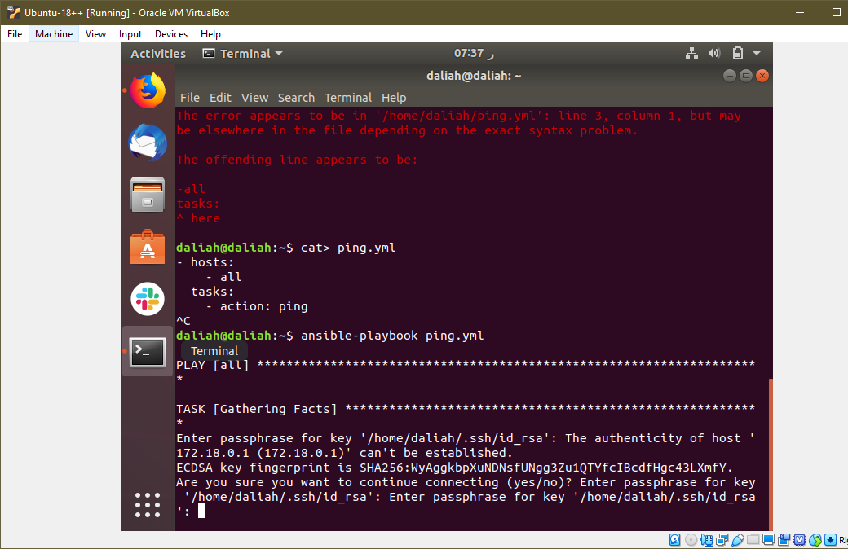

**Task #3 - Automate WordPress Installation  
Tip: Install ansible in ec2 instance.   
1- Create playbook to power on ec2 And install LAMP stack (Linux apache MySQL php)  
2- Create playbook to install and configure WordPress on the ec2 instance**

**-------------------------**

[1]"An Introduction to Configuration Management | DigitalOcean", *Digitalocean.com*, 2019. [Online]. Available: https://www.digitalocean.com/community/tutorials/an-introduction-to-configuration-management. [Accessed: 16- Jul- 2019].

[2]R. Ansible, "What is Ansible? | Ansible Quick Start Video", Ansible.com, 2019. [Online]. Available: https://www.ansible.com/resources/videos/quick-start-video. [Accessed: 16- Jul- 2019].